Evaluation under the spotlight for neighbourhoods
Newsletter Report on NRP Programme Development Meeting
August 2017

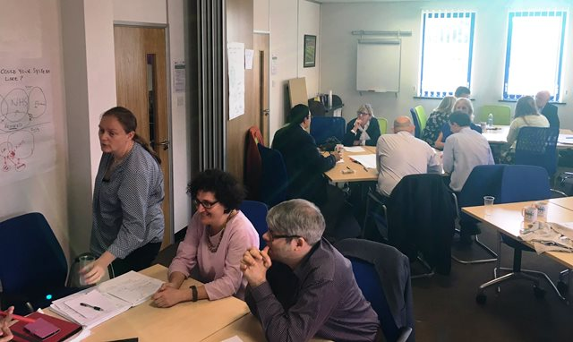
Key participants in CLAHRC NWC’s public health programme have met to discuss their role in evaluating this programme and the experience of engagement in the CLAHRC (pictured, left).
The public health programme is working to reduce health inequalities and improve public health through targeted action to enhance resilience in nine disadvantaged areas called Neighbourhoods for Learning. Importantly the programme is focused on the resilience of people who work in these neighbourhoods and the services they deliver, as well as the residents. For this reason it is called the ‘neighbourhood resilience programme’.
A series of learning and development sessions have been offered to support the on-going work of the programme which is now into it’s third year The aim of these sessions is to share experience and gain insight from the various issues that participants across the neighbourhoods have raised and local stakeholders are looking to examine. The role of residents is key to the programme and a number of local people are now enrolled as resident advisors for their neighbourhood.
An interactive session, planned in collaboration with the CLAHRC’s Local Authority partners, took place in August to begin to capture ideas about how the various participants in the programme could contribute to the programme’s process evaluation.
Paula Wheeler, COREN and Stakeholder Engagement Delivery Lead for CLAHRC NWC, said ‘’Earlier conversations are showing that a number of Resident Advisers are very interested in getting involved in the evaluation, and the next step for the programme is to design what this will look like. The idea for the development sessions is for the partners involved in the programme to inform that’’.
Human bingo kicked off the event to get people interacting before views on being part of the programme and how resident advisers wanted to shape the process evaluation moving forward were discussed.

